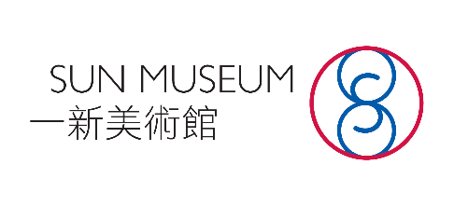
(內部專用 For Internal Use Only)
申請編號 Application No.: ______________
收表日期 Received Date: _______________

西源里選畫展覽申請表
Hong Kong Paintings in Sai Yuen Lane
Exhibition Application Form
*請在適當的空格加上剔號 Please tick as appropriate
申請人資料 Applicant Information
中文姓名(Name in Chinese) | 英文姓名(Name in English)
你是否香港永久性居民？  Are you a permanent resident of the HKSAR? |  | 是  Yes |  | 否  No
出生日期（日/月/年）Date of Birth(DD-MM-YYYY) |  |  | / /
聯絡電話Contact Telephone Number | 電郵地址 E-mail Address
聯絡地址 Correspondence Address

教育程度（按接受教育日期順序列出）Education (in chronological order)
就讀的學校、學院、大學  Schools, Colleges, Universities | 學系/主修學科Faculty/Major Area of Study | 課程名稱,就讀班級  Course and Year of Study | 就讀日期（月/年） Date (MM/YYYY)
 |  |  | 由 From | 至 To

請提供不多於300字的個人簡介。
Please provide your profile with no more than 300 words.

請列明曾有的展覽記錄、藝術獎項及藝術著作。
Please list your exhibitions, awards, and publications, if any.

一或兩件近期畫作 One or two recent paintings
*可包括中西的繪畫素材。（不接受裝置藝術、版畫及拼貼）
*The artworks could be Chinese or Western paintings.
(Installation, printmaking and collage art are not accepted)
作品一 Artwork 1
題目 Title
素材 Medium
尺寸（厘米X厘米）
Size (cm x cm)
創作年份 Year
創作概念（300字內）
Description (no more than 300 words)

請在此貼上作品的圖像
Please insert image(s) of the artwork

作品二 Artwork 2
題目 Title
素材Medium
尺寸（厘米X厘米）
Size (cm x cm)
創作年份 Year
創作概念（300字內）
Description (no more than 300 words)

請在此貼上作品的圖像
Please insert image(s) of the artwork

請問你從何處得知本次展覽的消息？
Where did you receive the information of this exhibition?
臉書 Facebook
Instagram
網頁 Website
電郵 Email
朋友 Friend
其他（請列明）Other (Please specify):

聲明 Declarations
- 本人已詳閱及同意「西源里選畫展覽申請指引」的申請細則及參展條款。
I have read and hereby agree to all terms of participations and conditions of the “Guidance Notes for Application for Hong Kong Paintings in Sai Yuen Lane Exhibition”.
- 本人特此聲明及保證，申請表的所有資料全部屬實。
I hereby declare and give an undertaking that, to the best of my knowledge, all information provided in the Application Form is correct and accurate.
- 本人同意主辦方將申請表所載資料轉交予參與本計劃之藝術機構/團體，以推行本計劃之用，包括但不限於甄選及面試等用途。
I hereby agree to and accept that the organiser shall transfer personal data in the Application Form to any art institution/group that participates in the exhibition, for implementing this programme, including but not limited to the selection and interview purposes.
簽署 Signature

__________________________

日期Date

___________________________

